|  |  |
| --- | --- |
| **LABORATORY ACTIVITY**  **No.1** | Advanced SQL |
|  |  |
| **Learning Outcome** | After completing this activity, you will be able to:   * Use SQL CREATE Commands |
|  |  |
|  |  |
|  |  |
| **Time to Complete** | 90 minutes |

**\*\*\*\*\*\*\*\*\*\*\*\*\*\*\*\*\*\*\*\*\*\*\*\*\*\*\*\*\*\*\*\*\*\*\*\*\*\*\*\*\*\*\*\*\*\*Start Here\*\*\*\*\*\*\*\*\*\*\*\*\*\*\*\*\*\*\*\*\*\*\*\*\*\*\*\*\*\*\*\*\*\*\*\*\*\*\*\*\***

**INSTRUCTION:**

1. Create a database named **EmpManagementDB_LastName.**
2. Create the tables shown in the diagram below.
3. Save your script as **Act1_LastNameFirstName.sql**

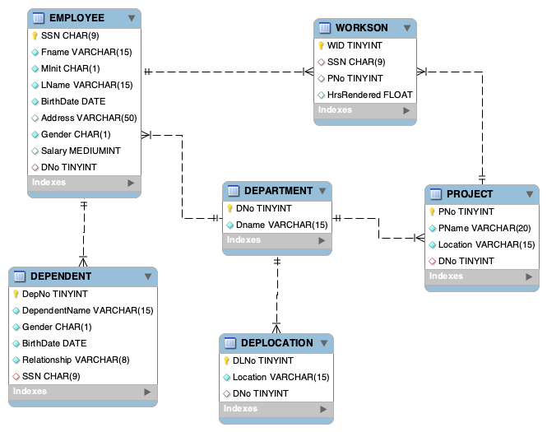

**CONTINUATION:** After creating your databases and its corresponding tables. You may now insert the following records for each table.

|  |  |  |  |  |  |  |  |  |
| --- | --- | --- | --- | --- | --- | --- | --- | --- |
| **Employee** | | | | | | | | |
| **SSN** | **FName** | **MInit** | **LName** | **Birthdate** | **Address** | **Gender** | **Salary** | **DNo** |
| 302366205 | Olivia | K | Williams | 1994-06-17 | 862 Vidon Circle, West Palm Beach, FL | Female | 97659.67 | 1 |
| 656579164 | Elizabeth | V | Phillips | 1970-05-30 | 75740 Oriole Place, El Paso, TX | Female | 54569.47 | 4 |
| 271904410 | Matthew | S | Brown | 1974-04-29 | 8 Kim Plaza, Miami, FL | Male | 48272.65 | 3 |
| 193149599 | James | B | Johnson | 2001-08-10 | 285 Manitowish Way, Denver, CO | Male | 90515.74 | 2 |
| 730672786 | Lillian | S | Anderson | 1984-10-09 | 56507 Old Shore Circle, Corpus Christi, TX | Female | 65255.17 | 5 |
| 688131442 | Martyn | D | Campbell | 1999-07-07 | 07 Westend Avenue, Louisville, KY | Male | 50982.73 | 6 |
| 438707370 | Daniel | D | Smith | 1979-01-31 | 86565 Holy Cross Junction, Jacksonville, FL | Male | 61079.34 | 4 |
| 320436077 | Harvey | M | Roberts | 1997-03-14 | 41 Pankratz Lane, Houston, TX | Male | 74099.57 | 2 |
| 755272504 | Victoria | I | Rodriguez | 1986-03-01 | 3 Bunker Hill Crossing, Spring, TX | Female | 20432.72 | 3 |
| 443119407 | Gianna | F | Walker | 1997-01-23 | 36075 Spohn Street, Fort Worth, TX | Female | 64124.9 | 6 |
| 767582066 | Grayson |  | Garcia | 1994-09-09 | 53264 Graedel Center, El Paso, TX | Male | 59755.76 | 4 |
| 500056990 | Michael | E | Hall | 1974-12-10 | 71 Southridge Hill, Tucson, AZ | Male | 64166.44 | 5 |
| 224027328 | Scarlett | P | Martinez | 1987-09-28 | 6 Chive Circle, Lexington, KY | Female | 25237.9 | 5 |
| 132850466 | Amelia | J | Adams | 1983-09-14 | 6693 Truax Avenue, Spring Hill, FL | Female | 24316.06 | 1 |
| 260407647 | John | L | Davis | 1986-11-17 | 53 Buell Hill, Laredo, TX | Male | 74633.62 | 1 |
| 473860457 | Sheilah | Z | Martin | 1997-05-31 | 62 Southridge Park, Louisville, KY | Female | 77207.42 | 6 |
| 295210671 | Gerald | L | Wilson | 1994-11-28 | 701 Mallory Drive, Orlando, FL | Male | 49883.02 | 5 |
| 850499675 | Kimmie | W | Baker | 1994-04-25 | 185 Weeping Birch Place, Gainesville, FL | Female | 77168.23 | 5 |
| 671596405 | Paisley | S | Thomas | 1998-04-24 | 4821 Anniversary Plaza, Fort Worth, TX | Female | 97919.58 | 3 |
| 435235662 | Andie | B | Miller | 1984-07-25 | 03 Valley Edge Trail, Boca Raton, FL | Female | 27338.5 | 4 |
| 466710302 | Sebastian | L | Scott | 1972-09-02 | 989 Milwaukee Trail, Louisville, KY | Male | 73575.37 | 2 |
| 488459661 | Emma | L | Wright | 1990-04-12 | 784 School Terrace, Laredo, TX | Female | 60963.69 | 3 |
| 136485560 | Addison | L | Jones | 1986-09-03 | 749 Red Cloud Hill, El Paso, TX | Female | 62702.46 | 6 |
| 588510442 | Randy | B | Moore | 1995-10-18 | 6402 Mcguire Parkway, Winter Haven, FL | Male | 15097.09 | 2 |

|  |  |  |  |  |  |  |  |  |
| --- | --- | --- | --- | --- | --- | --- | --- | --- |
| **Department** | |  | **Project** | | | |  | **\*** Abbreviation meaning **TX** : Texas  **FL** : Florida  **CO** : Colorado  **KY** : Kentucky  **AZ** : Arizona |
| **DNo** | **DName** |  | **PNo** | **PName** | **Location** | **Dno** |  |
| 1 | Finance |  | 1 | Lotlux | Houston, TX | 3 |  |
| 2 | Administration |  | 2 | Stim | Lexington, KY | 5 |  |
| 3 | Sales |  | 3 | Prodder | Midland, TX | 4 |  |
| 4 | Marketing |  | 4 | Voyatouch | Jacksonville, FL | 5 |  |
| 5 | Engineering |  | 5 | Flexidy | West Palm Beach, FL | 6 |  |
| 6 | Business Development |  | 6 | Quo Lux | Lexington, KY | 5 |  |
|  |  |  | 7 | Job | Austin, TX | 4 |  |
|  |  |  | 8 | Bitwolf | Lakeland, FL | 3 |  |
|  |  |  | 9 | Veribet | Gilbert, AZ | 5 |  |
|  |  |  | 10 | Zoolab | Houston, TX | 6 |  |

|  |  |  |  |  |  |  |
| --- | --- | --- | --- | --- | --- | --- |
| **Dependent** | | | | | | |
| **DepNo** | **DependentName** | **Gender** | **Birthdate** | **Relationship** | **SSN** |
| 1 | Ellie | Female | 2024-08-23 | Daughter | 302366205 |
| 2 | Wyatt | Male | 2010-10-08 | Son | 302366205 |
| 3 | Zoey | Female | 2023-03-13 | Daughter | 302366205 |
| 4 | Chloe | Female | 2021-08-21 | Cousin | 193149599 |
| 5 | Camila | Female | 2004-02-03 | Niece | 850499675 |
| 6 | Daniel | Male | 2020-11-25 | Grandson | 500056990 |
| 7 | Ethan | Male | 2010-02-15 | Grandson | 500056990 |
| 8 | Erinn | Female | 2015-07-05 | Sister | 443119407 |
| 9 | Mason | Male | 2006-12-31 | Son | 320436077 |
| 10 | Scarlett | Female | 2019-06-01 | Daughter | 132850466 |

|  |  |  |  |  |
| --- | --- | --- | --- | --- |
| **Workson** | | | | |
| **WID** | **SSN** | **PNo** | **HoursRendered** |
| 1 | 271904410 | 1 | 28 |
| 2 | 755272504 | 1 | 24 |
| 3 | 671596405 | 8 | 30 |
| 4 | 488459661 | 1 | 17.5 |
| 5 | 656579164 | 3 | 6 |
| 6 | 656579164 | 4 | 27 |
| 7 | 438707370 | 3 | 26 |
| 8 | 767582066 | 4 | 21 |
| 9 | 730672786 | 2 | 6.5 |
| 10 | 500056990 | 2 | 15 |
| 11 | 224027328 | 2 | 7 |
| 12 | 295210671 | 4 | 26 |
| 13 | 850499675 | 4 | 21 |
| 14 | 295210671 | 6 | 13.5 |
| 15 | 224027328 | 9 | 26 |
| 16 | 688131442 | 5 | 30 |
| 17 | 443119407 | 5 | 5 |
| 18 | 473860457 | 10 | 16 |
| 19 | 136485560 | 10 | 8.5 |
| 20 | 136485560 | 10 | 21 |

Below are Queries which you are going to solve.

In a new query file, write the appropriate SQL statements for each query and then save your SQL Scripts file with proper labels. Place your **Name (Lastname, Firstname)** in the First line of the file.

**FILENAME: 016Act2_Lastname**

Example:

-- Q0: Retrieve all Departments

SELECT *

FROM Department

--Q1: Retrieve the First name and Lastname of all Employees

SELECT Firstname, Last Name

From Employees

START HERE:

1. Retrieve the birth date and address of the employees whose name is ‘Martyn D. Campbell’
2. Retrieve the name and address of all employees who work for the ‘Marketing’ Department.
3. For every project located in ‘Lexington’, list the project number, the controlling department number and the department’s name.
4. Select all EMPLOYEE SSNs and their Dependents’ Name. SSN of employees without any dependents must also be displayed.
5. Retrieve all distinct salary values.
6. Make a list of all project numbers for projects that involve an employee whose last name is ‘Jones’
7. Retrieve all employees whose address is in ‘Louisville, Kentucky’